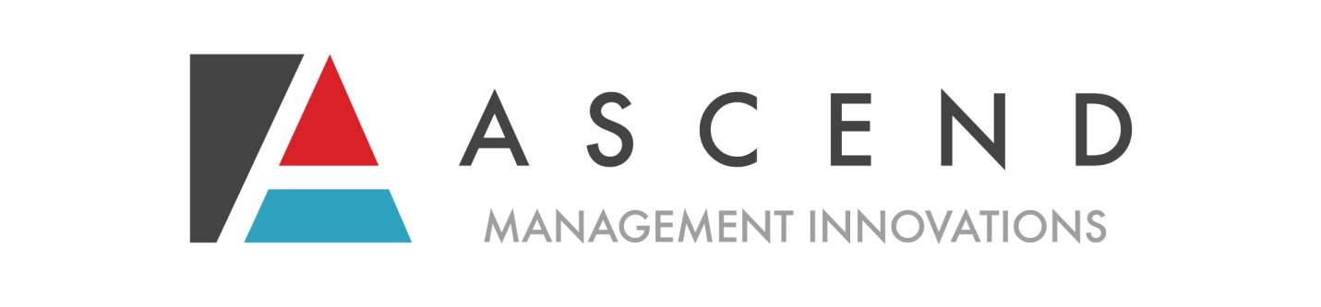

VIRGINIA SIS® SATISFACTION SURVEY REPORT
January 2019 – March 2019

Virginia SIS® Satisfaction Survey

This report compiles the results of Ascend Management Innovations’ Supports Intensity Scale® satisfaction surveys for the time period of January 2019 through March 2019.

Background
Ascend, A MAXIMUS Company, contracts with the Department of Behavioral Health and Developmental Services (DBHDS) to perform SIS® interviews to transform Virginia’s Intellectual and Developmental Disability (IDD) service system by expanding service capacity, strengthening community-focused services, promoting self-determination, and encouraging individuals to actively participate in all aspects of community life. Virginia uses the conflict-free, objective SIS® assessment to establish individual resource allocation. The Virginia SIS® project began in October 2014. As a part of Ascend’s continuous quality improvement model, satisfaction data is collected for SIS® interviews. Satisfaction data is used to identify training opportunities and procedural changes for Ascend’s scheduling department and the independent contractor interviewers. Respondent feedback is also provided to DBHDS for program analysis and planning.

Methodology
Following each SIS® interview, all respondents including SIS® recipients, family members and guardians, support coordinators, and providers are offered a SIS® Satisfaction Survey form and invited to submit their feedback. Respondents may fax or mail the completed surveys to Ascend’s corporate office. Survey results are compiled and analyzed by Ascend’s Quality Improvement Department for review and trending. Result outliers, significant positive or negative feedback, are immediately forwarded to the VA SIS® Manager for review, action planning, or complaint resolution as appropriate.
Stakeholders are asked to identify their satisfaction for seven questions on a Likert scale of 1 to 5, 1 being disagree and 5 being agree. The questions identify respondent satisfaction with the process, effectiveness, and professionalism of Ascend’s scheduling department, as well as the professionalism and skill of the interviewer:
- The interview was scheduled at a convenient time/date.
- The scheduler was courteous and communicated clearly.
- The individual’s support team was well represented at the assessment.
- The interviewer was courteous and communicated clearly.
- The interviewer treated me/us with dignity and respect.

- The interviewer conveyed interest and took the time to learn about the individual’s support needs.
- The interviewer effectively captured the individual’s support needs.
In addition, respondents are asked to identify if the interviewer arrived on time to the interview and the length of the interview. These data points gauge the interviewer’s ability to meet professional expectations and his or her interview administration skills.
Finally, respondents are invited to provide narrative feedback regarding:
- The assessment tool and its uses (feedback to the state)
- Scheduling
- The interviewer
This report will detail the results of 156 satisfaction surveys received or 12% of the 1,313 SIS assessments completed from January 2019 through March 2019.

 | Agree | Somewhat Agree | Neutral | Somewhat Disagree | Disagree | No answer
The interview was scheduled at a convenient time/date | 95% | 3% | 1% | 0% | 1% | 1%
 | 148 | 5 | 1 | 0 | 1 | 1
The scheduler was courteous and communicated clearly | 96% | 1% | 1% | 0% | 1% | 1%
 | 149 | 2 | 2 | 0 | 2 | 1
The individual's support team was well represented at the assessment | 97% | 1% | 1% | 0% | 0% | 1%
 | 152 | 2 | 1 | 0 | 0 | 1
The interviewer was courteous and communicated clearly | 99% | 1% | 1% | 0% | 0% | 0%
 | 154 | 1 | 1 | 0 | 0 | 0
The interviewer treated me/us with dignity and respect | 99% | 0% | 1% | 0% | 0% | 0%
 | 155 | 0 | 1 | 0 | 0 | 0
The interviewer conveyed interest and took the time to learn about the individual's support needs | 99% | 1% | 0% | 0% | 0% | 0%
 | 154 | 2 | 0 | 0 | 0 | 0
The interview effectively captured the individual's support needs | 98% | 1% | 0% | 1% | 0% | 0%
 | 153 | 2 | 0 | 1 | 0 | 0

Representative Comments
Assessment tool and its uses:
- “There are some topics that did not fully capture the individual, but overall the assessment tool captured everything else. There also should be an area in the assessment that better captures the environment and tools utilized in the person’s home to assist in maintaining stability and assisting with the person’s ability to think in certain areas”
- “It’s a very uncomfortable process and I am not sure that it accurately addresses all of my son’s areas of vulnerability and need. I am concerned about how it will be used to determine service packages”
- “Lifelong learning section not particularly helpful”
- “Some sections can be difficult on family members who have a loved one that is total care”
- “Very comprehensive, encourages the individual and the team to discuss all aspects of his/her life”
- “Very handy and helped the meeting go smoothly”
- “The tool was long and through and it took a long time to complete. However, I think we have a fairly accurate picture of my grandson”
Scheduling:
- “No, the time was scheduled too late in the afternoon and on a Friday”
- “Individual had to miss a day of school for the assessment”
- “Needs to improve so that SIS are not scheduled too far beyond expiration date of current SIS on file”
- “No issues-the team met at a convenient time”
- “The scheduling met everyone’s needs for a convenient date and time, especially location”
- “The SIS was scheduled way in advance”
- “Very accommodating & several reminder calls”
The Interviewer:
- “She was kind, but often questioned our responses”
- “The assessor is great. She is professional, takes the time to capture everything that is being conveyed about the individual. She explains everything mainly instructions thoroughly and reminds one of the instructions if not clear. I would completely recommend her as an assessor”
- “Overall great experience. Interviewer is knowledgeable and caring”
- “Assessor is a pleasure to work with and is very good at communicating clearly to be sure we get the most accurate picture of supports needed”
- “Assessor was very person centered. He made a difficult process less distressing. I like his beginning the process by having everyone acknowledge a positive quality of my son. He was very professional but very friendly”
- “The assessor is a great interviewer. She gives everyone time to talk about each question to come up with the best support for the individual”.
- “Interacted well w/individual, friendly and knowledgeable”

