

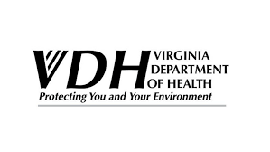

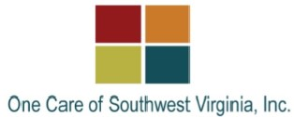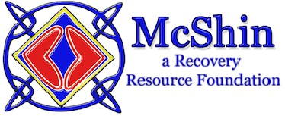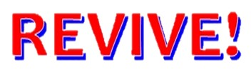

HOW TO RECOGNIZE AND

RESPOND TO AN OPIOID

OVERDOSE EMERGENCY

WITH NALOXONE

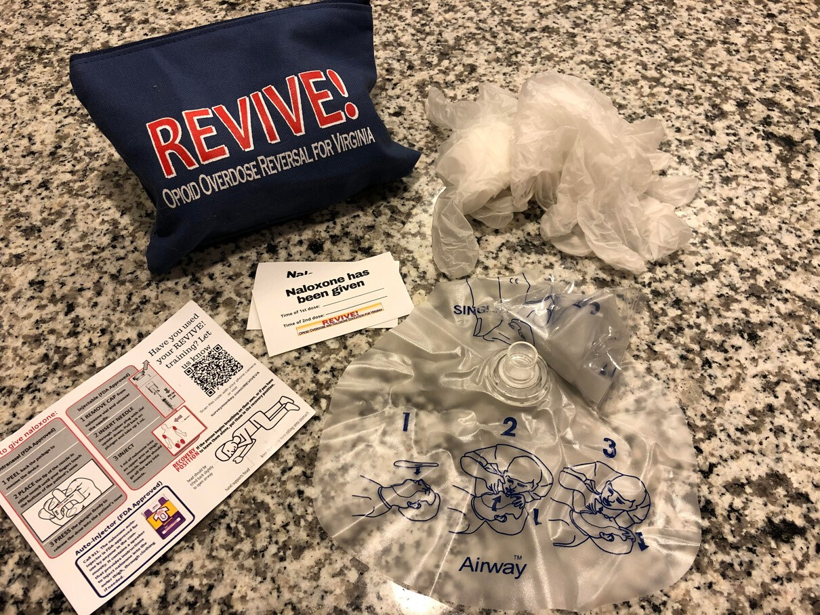

Naloxone only works if opioids

are in the body, it has no

effect on alcohol or other

drugs

It can take

minutes

1-3

to

start working and may require

more than one dose.

Effects can

last 30-90

minutes

, this varies per

person.

Naloxone may cause an

opioid dependent person to

go into

withdrawal

e.g.

(

nausea, vomiting, agitation,

muscle aches).

Naloxone is a medication

designed to temporarily

block

the effects of opioids

, and can

reverse overdose.

Naloxone Saves

Lives.

PO Box 1797

Richmond, VA 23218

ADDRESS

dbhds.virginia.gov search "revive"

Revised September 2021

WEB

WHAT IS

NALOXONE?

An opioid overdose can happen to

anyone taking opioids —

whether they are taking medications

prescribed or using them

recreationally. Opioids can cause a

person’s

breathing to slow down or

stop

— this is considered an overdose.

Latex-free gloves

Rescue breathing face mask

Instruction Card

A training completion card

And stickers to document time of

administration

To learn more about using naloxone

attend a REVIVE! training event!

These events are

free and

available to anyone

wanting to

learn how to save a life with

naloxone.

A REVIVE! Opioid Overdose

Response Kit is provided at each

training free of charge and

inlcudes:

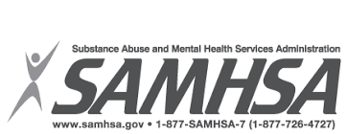

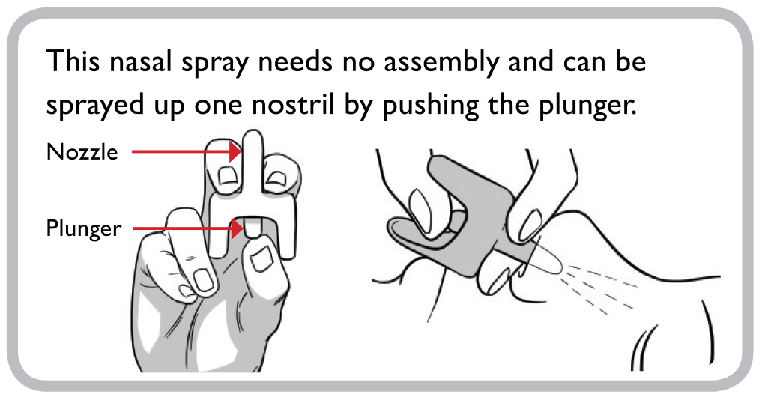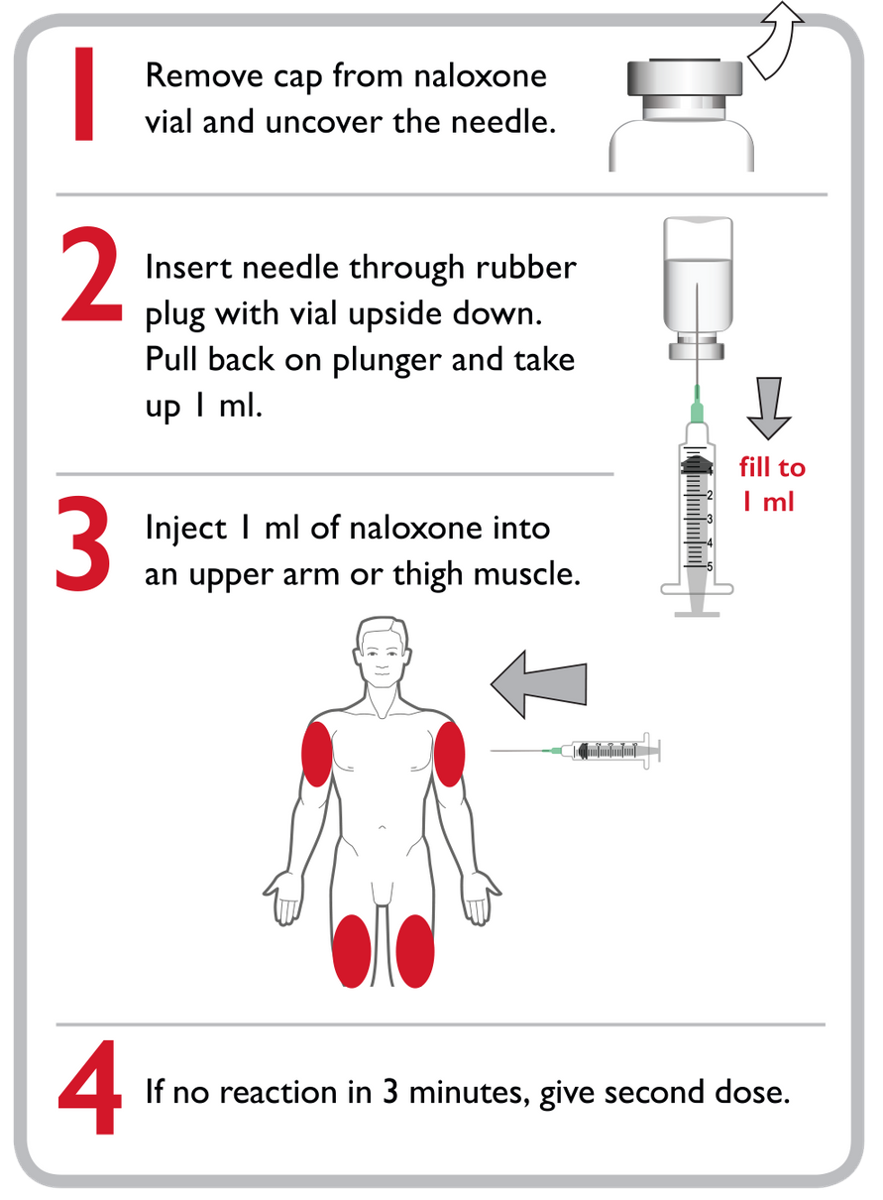

Hydrocodone

Oxycodone

Morphine

Codeine

Tramadol

Buprenorphine

Methadone

Opioids are a class of drugs that

includes prescription pain

medications like:

*and also street drugs like heroin and fentanyl

When a person consumes more

opioids than their body can

tolerate it can stop central

nervous system functions such as

breathing and heartbeat.

Mixing drugs

Lowered Tolerance (haven't

used opioids before or in a

while)

Using alone

Age and Physical Health

Mode of Transmission

Previous non-fatal overdose

Some of the primary risk factors

associated with overdose are:

RESPOND

Naloxone expires, visit

dbhds.virginia.gov to

learn where you can get

naloxone at no-cost.

REDUCE RISK

Use Naloxone if you suspect

someone is overdosing, even if

you are unsure.

OPIOIDS

OVERDOSE

Check for responsiveness

Call 911

Give 2 Rescue Breaths

Give Naloxone

Begin Rescue Breathing

If you suspect someone has

overdosed:

1

.

2

.

3

.

4

.

5

.

Unresponsive to yelling,

pinching, or a sternum rub

not breathing or having

really slow/shallow breaths

Having blue lips and/ or

fingertips

Someone may be overdosing

if they are

USING NALOXONE

**Narcan Nasal Spray (FDA Approved)**

**IM Injection (FDA Approved)**

**Three ways to obtain Naloxone:**

* **Local Health Department* (no cost)**
* **Community Services Board (no cost)**
* **Local Pharmacy (Insurance/out-of-pocket**

**\*not all health departments offer naloxone**