REVIVE! How to Guide for Trainer’s – April 2022

Background
On November 21, 2016, the former State Health Commissioner, Dr. Marissa Levine, declared the Virginia opioid crisis a Public Health Emergency and it continues today. Since 2013, fatal drug overdose has been the leading method of unnatural death in Virginia and opioid overdoses have been the driving force. On average, more than 3 people die each day from an opioid overdose in Virginia. These overdoses occur in urban, rural, and suburban communities across the state.
In addition to the Public Health Emergency declaration, Dr. Levine issued the first statewide standing order for naloxone, making this life-saving drug available to every person in Virginia without needing to obtain a doctor’s order. The Good Samaritan Law (§8.01-225) permits any person, in good faith, to administer naloxone to someone who is experiencing an opioid overdose. Virginia Law (§54.1-3408) permits any person who has received instruction to carry and possess naloxone legally. These laws apply to private citizens and professional first responders including non-medical personnel such as law enforcement.

Training Overview
The creation of this course is to educate and train Virginians to recognize and learn how to respond to an opioid overdose emergency with the administration of naloxone.

This training will take one to one and half hours. It utilizes slide presentation, discussion, and demonstration.
Materials needed for this course include:
- Laptop or Computer
- Projector (Audio Visual Equipment)
- PowerPoint slides
- Naloxone (or knowledge of community referral)
- Naloxone demonstration models (optional)
- REVIVE! kits
- Mannequin
- Copy of relevant protocols (if training occurs at agency)
- Training evaluation forms (or digital format) Using the Trainer’s Guide
This curriculum contains the following materials to prepare and conduct the training:
- Agenda
- PowerPoint slides with trainer notes and key talking points
• Appendices:
  - REVIVE! Evaluation Form
  - Additional Resources

Naloxone Dispensing
This training is most effective when participants have naloxone dispensed at the time of training. If naloxone is not dispensed at the training, please be sure to learn where individuals can receive naloxone in their community.

Additional Resources
Please visit http://dbhds.virginia.gov/behavioral-health/substance-abuse-services/revive for additional resources available to first responders for obtaining naloxone, updates on training, and additional guidance.

Training Agenda
Below is an outline and sequence of sections, key topics, and the estimated time needed to cover each section.

Section |  | Key Topics | Time | Slides
Introduction | - Introductions  - Course objectives |  | 2 minutes | Slides 1-2
The Opioid Epidemic in Virginia | - The Opioid Crisis  - Fatal Drug Overdose Data |  | 2 minutes | Slides 3
Virginia Allowances for Overdose Response | - Virginia’s Good Samaritan Law  - Safe Reporting of Overdoses law  Standing Order |  | 5 minutes | Slides 4-6
Opioid Overdoses & Naloxone | - Opioids  - Opioid Overdoses  Risk factors for Overdose Naloxone |  | 20-25 minutes | Slides 7-26
Naloxone Recommendations | - How to store Naloxone  - Safety of Naloxone |  | 5 minutes | Slides 27-28
Steps of opioid overdose response | - Signs of overdose  - Respiration support  - Administration of naloxone (demonstration)  - Monitoring and follow up |  | 15-20 minutes | Slides 29-39
Hands-on Training (in-person only) | - Ask participants if they would like to practice |  | 10-20 minutes | Slides 40
Additional Information | - Testimonials  - REVIVE! Kits  - Responder’s Fatigue |  | 10 minutes | Slides 41
Wrap-up | - Q+A discussion  - Course evaluation |  | 5-10 minutes | Slides 42 & 43
75-90 minutes

This training should not be altered without consent from the Virginia Department of Behavioral Health and Developmental Services.

PowerPoint Presentation and Training Slides

Slide 1 | 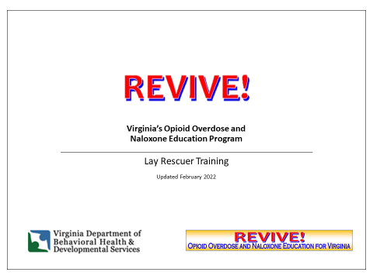 | Welcome participants to the training. Introduce yourself and your role and ask any co-presenters to introduce themselves. “The purpose of this training is to give you more information and skills to respond to overdoses and save lives in your community.”  Trainer note: you may find it useful to ask a few brief questions to get familiar with the audience’s experience with opioid overdose.
Slide 2 | 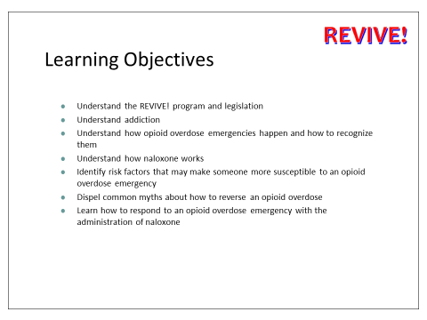 | Review the objectives.
Slide 3 | 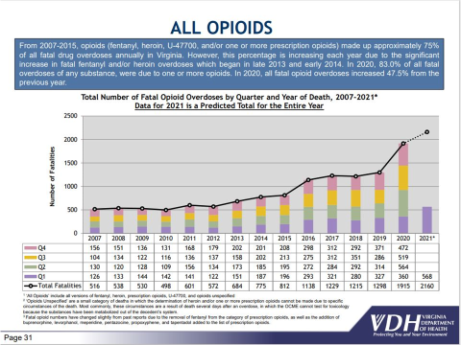 | Review slide as written.  Trainer note: In 2019, there were 1,289 deaths from opioid overdoses; all fatal opioid overdoses increased 6.1% from the previous year. This same year 79.7% of all fatal overdoses of any substance were due to one or more opioids. The data shows in 2021, overdoses were higher than all previous years during the first half of the year. This indicates opioid overdoses are continuing to increase, which validates the importance of this training.
Slide 4 | 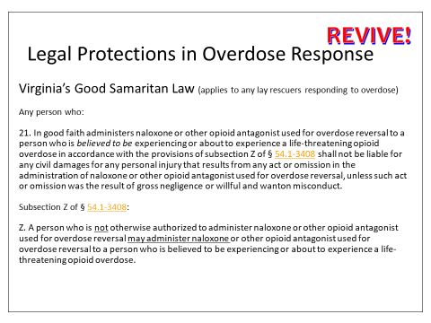 | Review slide as written.  Virginia also included naloxone administration into its Good Samaritan Law to provide protections for both citizens and first responders in the case of an opioid overdose.
Slide 5 | 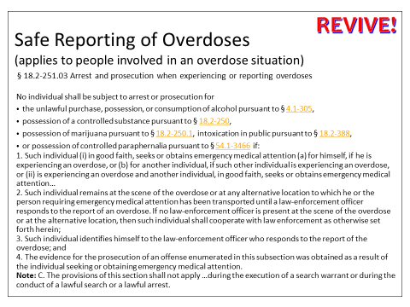 | Review slide as written.  Trainer note: To get you to the scene of an overdose, people need to call 911 or seek help. Many individuals, however, are reluctant to call 911 or seek help because they want to avoid law enforcement involvement. To address this concern, Virginia passed the Arrest and prosecution when experiencing or reporting overdoses law in 2020. This law replaced the previous Safe Reporting of Overdoses law and now provides protection for the person overdosing.
Slide 6 | 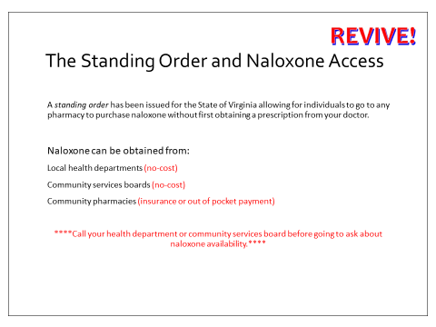 | In 2016, the opioid epidemic was declared a public health emergency and with that declaration naloxone access increased. The standing order issues a “blanket prescription” for every person in Virginia. Individuals can obtain naloxone from pharmacies just like a flu vaccine – no prescription required – or from other groups that are dispensing naloxone.
Slide 7 | 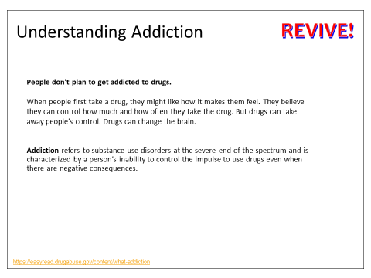 | Although it is not possible to understand addiction in this short amount of time, refer to it as the severe end of the spectrum of a Substance Use disorder. It may be helpful to give examples as to why individuals use substances (to do better, to feel better, cope with stress, etc). Use this as a gateway to explain why naloxone may be one of the safest forms of harm reduction for someone with an opioid use disorder, if they are not ready to seek treatment.
Slide 8 |  | Play the video.  Create a group discussion after the video.  What do you think after watching this? What did you notice about the kiwi (bird)? What changes did you notice in the environment? For more talking points please see the appendix.
Slide 9 | 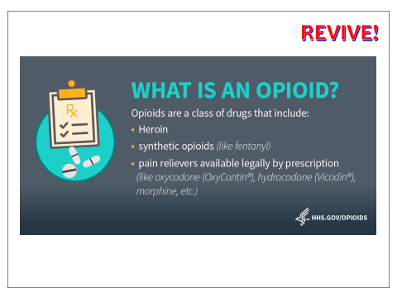 | Review slide as written.
Slide 10 | 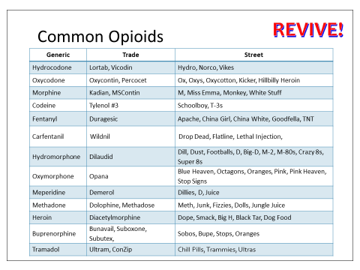 | Briefly overview these opioids. You do not need to review all of the street/trade names.
Slide 11 | 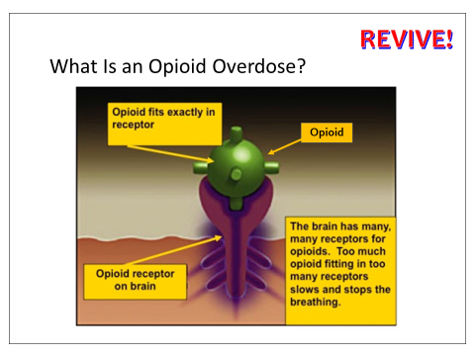 | Mention that the opioids perfectly fit onto the  receptors. Opioids are supposed to relax a person, they allow people to get rest when treated medically with prescription opioids by slowing the heart rate and breathing rate. Overdoses happen when it slows those down too much.
Slide 12 | 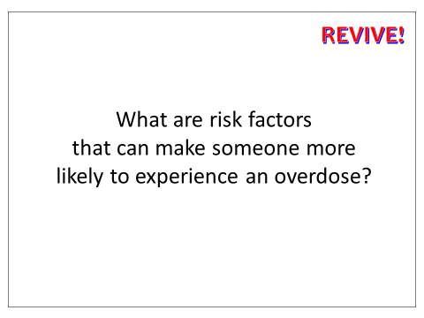 | Ask for group engagement.
Slide 13 | 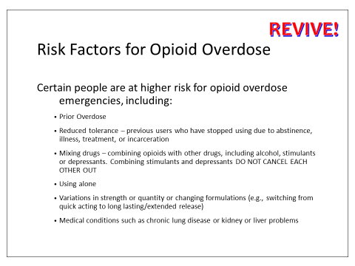 | Review slide as written.  Overdose happens in all age groups and in all contexts of opioid use—from long-term heroin users, to patients prescribed painkillers, to young people experimenting with drugs.  One of the most frequent causes of overdose is when a person begins using opioids again after a break in use. After a break in use, tolerance to opioids goes down and the body cannot handle as much as it did before. If a person uses the amount of opioids they did before the break, they may overdose because they cannot tolerate the amount. Many opioid overdoses occur with other drugs especially with other drugs that slow down breathing like benzodiazepines (such as Xanax or Valium), sleep medications, and alcohol. Cocaine and methamphetamine deaths are on the rise and frequently combined with opioids. Illicitly purchased drugs are often stronger than expected or a different drug entirely. People who have overdosed before are more likely to overdose again, due to riskier practices. Finally, using opioids when no one else is present does not cause an overdose, but increases the likelihood that the overdose will be fatal as no one is there to help.
Slide 14 | 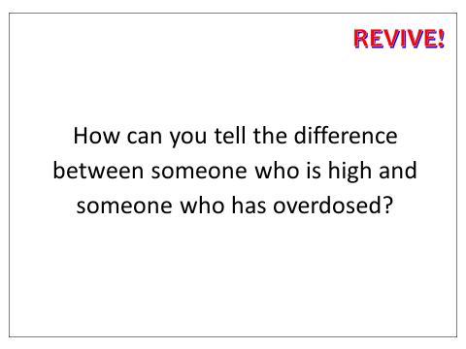 | Ask for group engagement.
Slide 15 | 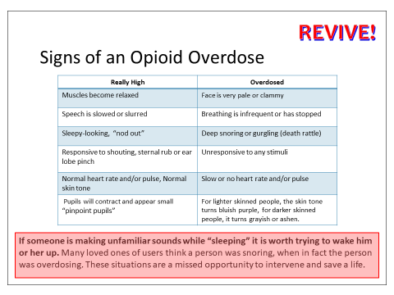 | Review slide as written.
Slide 16 | 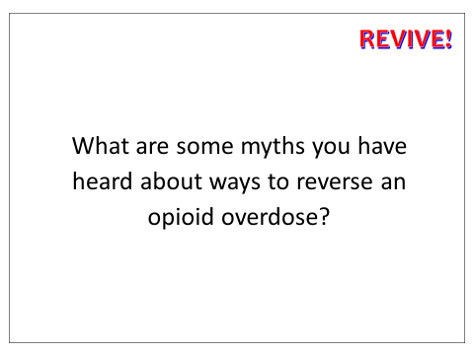 | Ask for group engagement.
Slide 17 | 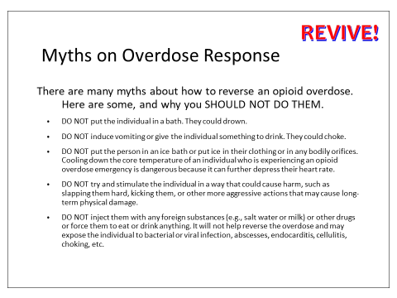 | Review slide as written.  Trainer note: When you review this slide, it is important to respect the individuals that perform these measures to save their loved ones/friends lives. The goal of the REVIVE! program is to provide education on what to do during an opioid overdose especially to those who have historically not had access to this information.
Slide 18 | 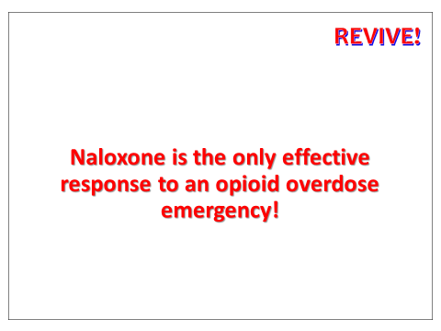 | Review slide as written.
Slide 19 | 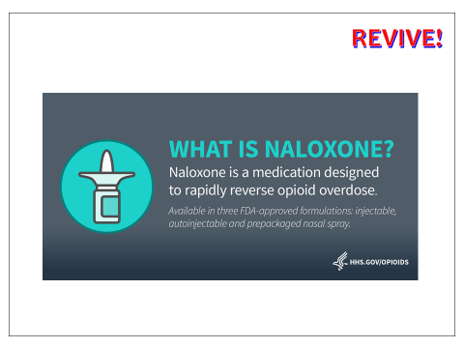 | Review slide as written.
Slide 20 | 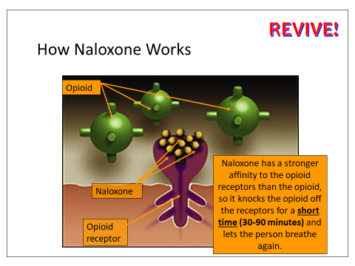 | Review slide as written.
Slide 21 | 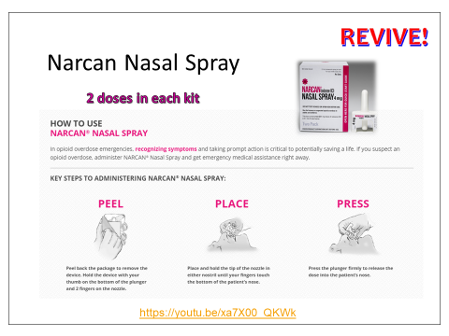 | Review the slide as written.  Demonstrate with practice device.  Trainer note: A person does not have to be breathing to receive nasal naloxone, it is actually designed to be given to someone not breathing and gets absorbed by the mucus membranes.  Show video and ask if there are any additional questions.
Slide 22 | 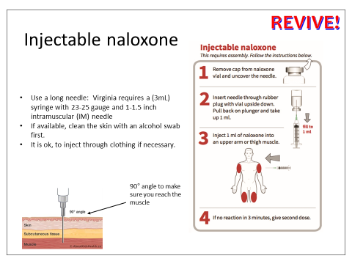 | Review slide as written.  You may mention that the IM formula is available, as it was not taught during this training before.
Slide 23 | 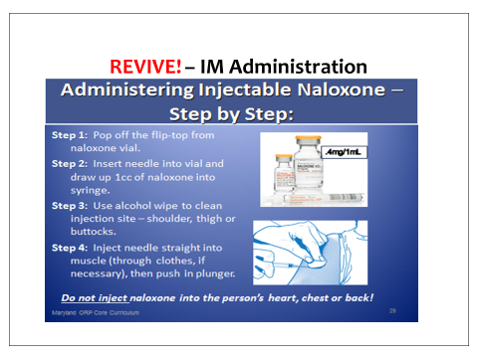 | Review slide as written.  Trainer’s note: Injecting into the chest has come up quite a bit, in reference to a scene in the movie “Pulp Fiction”. You may emphasize the instructions to NOT inject into the chest, back or heart.
Slide 24 | 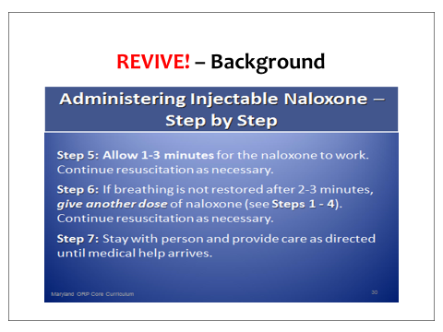 | Review slide as written.
Slide 25 | 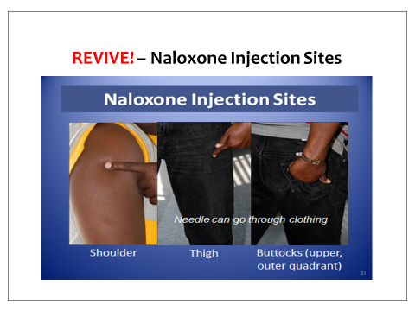 | Review slide as written.  This gives a visual of the correct muscles to inject the IM formula.
Slide 26 | 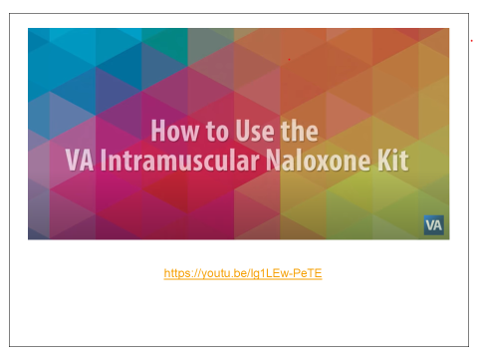 | Show video.  Ask if there are any questions regarding the IM formula administration.
Slide 27 | 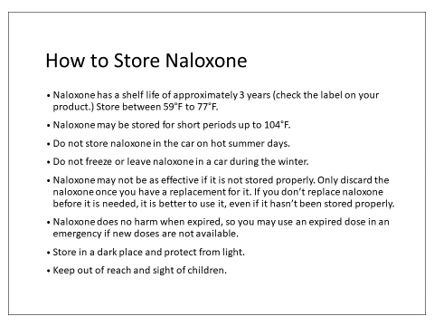 | Review slide as written.
Slide 28 | 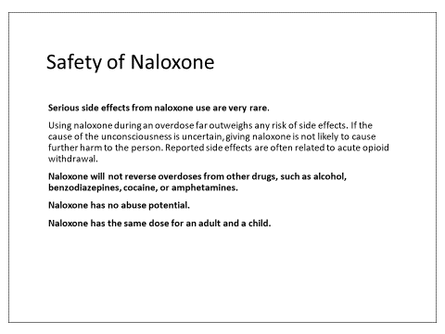 | Review the slide as written.
Slide 29 | 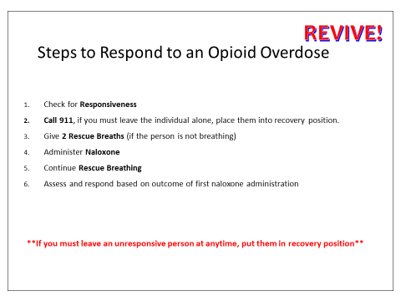 | Review slide as written.  Trainer note: Apply gloves.
Slide 30 | 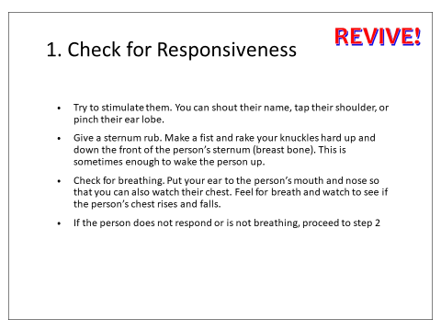 | Review slide as written.  Demonstrate on the manikin.
Slide 31 | 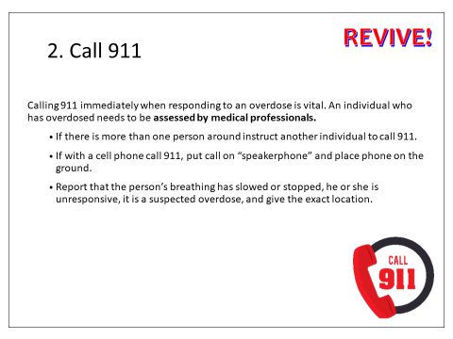 | Review slide as written.  Demonstrate on the manikin.
Slide 32 | 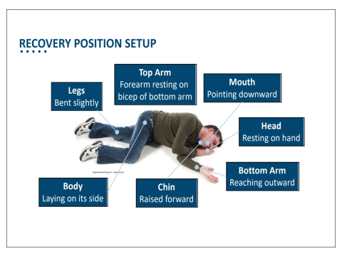 | Review slide as written.  You may emphasize that you would only use this step if you have to leave the person unattended. Also, mention to only leave the person unattended if completely necessary (i.e. to grab Naloxone, to remove obstacles for EMS/unlock door, grab a phone to call 911).
Slide 33 | 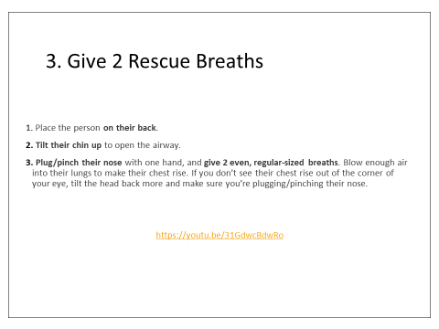 | Review slide as written.  Demonstrate on the manikin. Trainer note: Note the pocket shield in the REVIVE! kit, shows participants what it looks like and show the images. Here you want to highlight the importance of opening the airway for breaths to be effective.  Show video and ask if there are any questions.
Slide 34 | 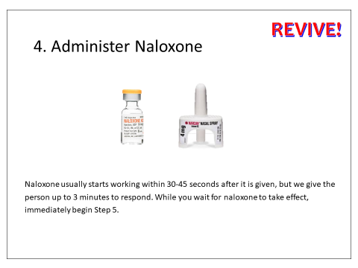 | Review slide as written.  Demonstrate on the manikin.
Slide 35 | 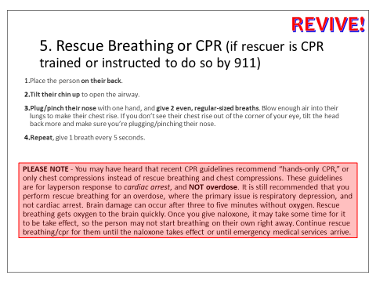 | Review slide as written.  Demonstrate on manikin.
Slide 36 | 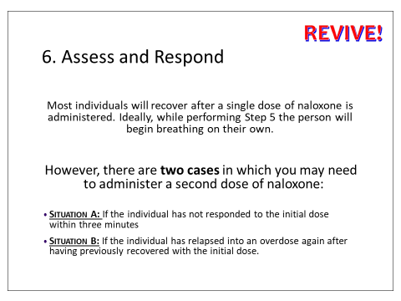 | Review slide as written.  Trainer note: It can be beneficial if you are acting out scenarios on the manikin. For example, “Ideally Bob will recover from this overdose within a minute or so of receiving naloxone. However, there are two situations when we may have to give a second dose.  The first would be if I have been on Step 5, giving rescue breathing for 3 minutes. The other would be if Bob recovered, he became conscious and was breathing on his own, but then he became unresponsive again.”
Slide 37 | 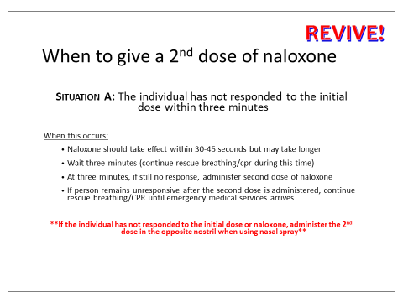 | Review slide as written.
Slide 38 | 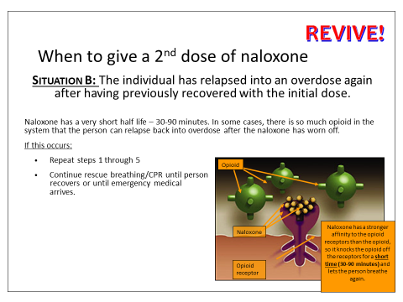 | Review the slide as written.  Trainer note: The image illustrates that when naloxone works it does not destroy the opioids in the system, so they can reattach when naloxone wears off. It also highlights the short period of time naloxone works.
Slide 39 | 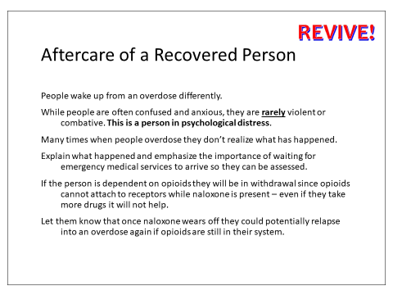 | Review slide as written.
Slide 40 | 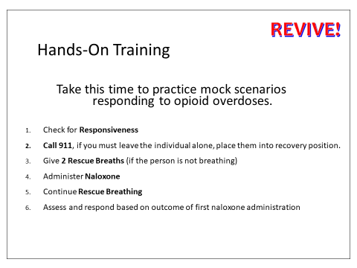 | For in-person trainings, this very important. Use scenarios for persons to practice going through the steps.
Slide 41 | 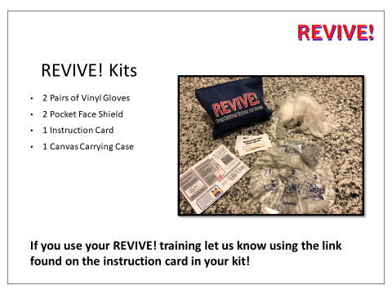 | Review the REVIVE! kits that have been provided to attendees.  Trainer note: Emphasize naloxone is NOT provided in the kit and revisit the three ways of obtaining it. Reference the REVIVE! completion card. This card will indicate that the person has completed training and does not need an additional training when obtaining Naloxone, unless they would like to receive additional training.
Slide 42 | 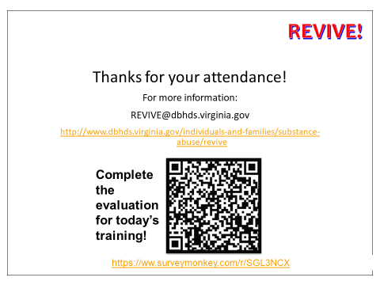 | Have those with smartphones:  - Launch your camera.  - Point it at the QR code.  - Press and hold the home button.  - Tap to trigger the code's action.  For others provide the weblink for the evaluation or provide paper evaluations
Slide 43 | 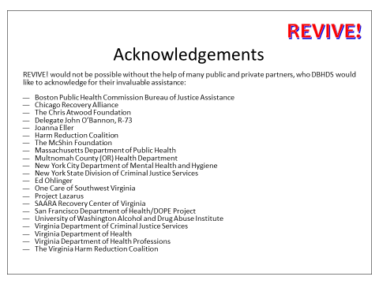 | Conclude the training and ask if there are any additional questions or comments before ending the training.

