Opioid Overdose and Naloxone Education— Patient Handout
What are opioids?
Opioids are a class of drugs including heroin and prescription pain medications including: Hydrocodone Oxycodone Fentanyl Morphine Codeine Methadone Buprenorphine What is an opioid overdose?
Opioids can cause a person’s breathing to slow down or stop— this is considered an overdose.
Who is at risk of an overdose?
Persons:
Leaving emergency care for overdoses
Lost tolerance— due to detox, incarceration, abstinence based treatment
Enrolled in treatment programs In active drug use
What is naloxone?
Naloxone temporarily blocks the effects of opioids, and can reverse overdose.
Naloxone only works if opioids are in the body, it has no effect on alcohol or other drugs It can take 1-5 minutes to start working and may require more than one dose.
Effects can last 30-90 minutes, this varies per person
Naloxone may cause an opioid dependent person to go into withdrawal (e.g. nausea, vomiting, agitation, muscle aches). These symptoms will go away as the naloxone wears off.
What does an overdose look like?
A person is unresponsive (they won’t wake up even if you yell or shake them)
Give the person a sternal rub—rake your knuckles up and down on the front of the rib cage in the middle of their chest.
Slow or no breathing
Lips and/or fingernails turn blue, pale, or gray

What to do in case of an overdose?
- Check for Responsiveness.
- Call 911 Follow dispatcher instructions.
- Give 2 Rescue Breaths. for a few quick breaths if the person is not breathing.
- Give naloxone See reverse for instructions. If no reaction after 3 minutes, give second dose.
- Give rescue breaths or CPR (if you know how or are instructed to by 911) until the person responds. Rescue breathing: Tilt head back. Pinch nose. Give 1 breath every 5 seconds, repeat. 6. After care Stay with the person as long as you can or until help arrives. Make sure the person doesn’t take more opioids. If you must leave the person, place them on their side in recovery position.
If you don’t have naloxone; call for help and give rescue breaths.

Administering Naloxone:
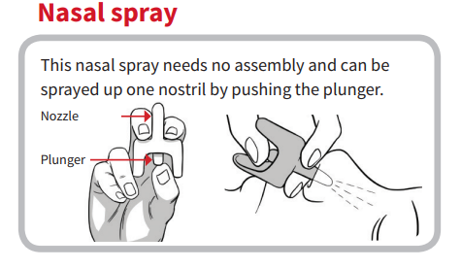 | 