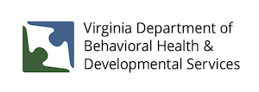

February 1, 2023

Pursuant to language in the 2022 Appropriations Act, DBHDS posts information to its website on a quarterly basis regarding the number of new slots for the fiscal year that have been allocated by community services boards and of those, how many people are accessing services.

The following information is provided for the second quarter of FY 2023.

There were no new DD waiver slots funded for FY 2023. Therefore, none were allocated to CSBs or assigned to individuals. This resulted in no individuals accessing services via new slots

