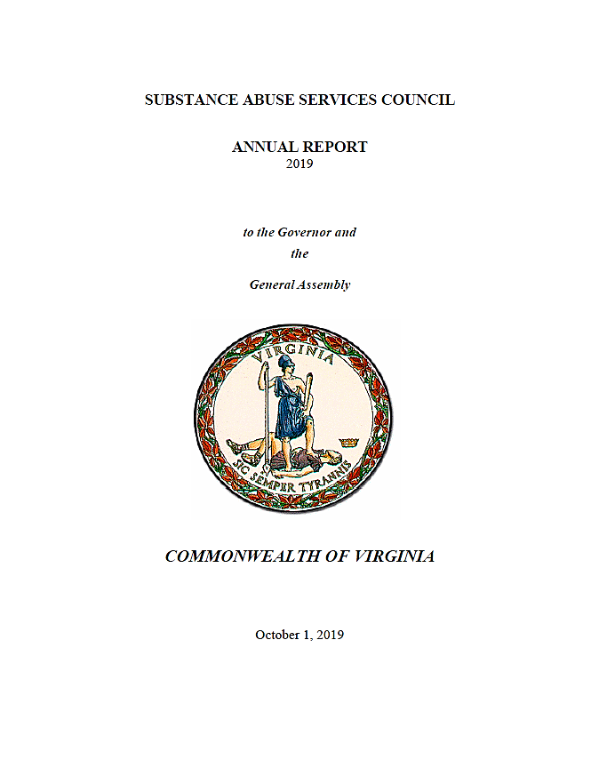

**2022**

**October 25, 2022**



October 25, 2022

To: The Honorable Glenn Youngkin, Governor

Members, Virginia General Assembly

Fr: State Senator John Bell, Council Chair

In accordance with §2.2-2696 of *Code of Virginia*, I am pleased to present the 2022 Annual Report Letter of the Substance Abuse Services Council (SASC). The *Code* charges the council with recommending policies and goals relating to substance abuse and dependence and with coordinating efforts to control substance abuse which is included in the Interagency SASC Report. It also requires the council to make an annual report in the form of this letter on the presentations it received and its activities. The membership of the council includes representatives of state agencies, state delegates, state senators, and representatives of provider and advocacy organizations appointed by the Governor.

On behalf of the council, I appreciate the opportunity to provide you with our annual report identifying major themes in the council’s work in 2022 and highlighting focuses, contributions, and recommendations from the council based on its work this year. We hope it will contribute to improving the lives of the many Virginians affected by substance use disorders.

Sincerely,

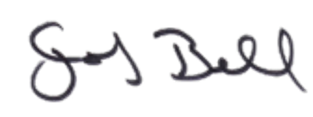

State Senator John Bell

SASC Chairperson

Cc: The Honorable John Littel, Secretary of Health and Human Resources

Nelson Smith, Commissioner, Department of Behavioral Health and Developmental Services (DBHDS)

**2022 SASC Annual Report Overview**

In 2022, during a year in which opioid related deaths continued to climb and other challenging variables emerged including expansion of marijuana and gambling legalization, SASC continued its duties in collecting information, receiving presentations, and utilizing its multidisciplinary network of leaders in the substance used disorder (SUD) field to better inform policy and practice in the public and private sectors about reducing barriers to treatment and prevention. In 2022, SASC began to meet in person again after Governor Youngkin lifted the COVID-19 State of Emergency in Virginia. SASC was able to meet three times and will make attempts to meet a 4th time late this year. During those meetings, SASC representatives shared agency and legislative updates, received presentations from experts across the behavioral health field, shared recommendations and initiatives amongst governmental agencies, community organizations, and private providers, and heard public comment. Additionally, SASC continued to fulfill its advisory capacity to DBHDS and the Commonwealth regarding requests for information and recommendations for improving policy and procedure.

**Legislative Initiatives Endorsed by SASC during 2022**

1. **HB 277 Recovery residences - *Passed***; Requires that all recovery residences be certified by DBHDS and that they comply with minimum square footage requirements related to beds and sleeping rooms. The bill also requires recovery residences to disclose to potential residents whether it is credentialed by National Alliance for Recovery Residences and how much support they receive or by Oxford House, Inc. in which case they need to inform them that the residence is self-governed and unstaffed. The bill also requires DBHDS to include such information on the list of all recovery residences maintained by the Department on its website. The bill exempts recovery residences from the provisions of the Virginia Landlord and Tenant Act.
2. **SB 425 Barrier crimes - *Passed in Senate but not House*;** This proposed legislation would have eliminated certain barrier crimes which in the substance use treatment and prevention fields prohibit a significant portion of peers with lived experience from being employable despite a large workforce shortage. This legislation would have mandated the creation of a waiver process for individuals with a barrier crime on their record either currently working or seeking employment at an employer which if approved could then waive the restrictions that those crimes face in terms of being employed.
3. **Budget Amendment SB 30 Item 304 #2s - Medicaid Peer and Family Support Rate Increase-**

*Passed* - Effective July 1, 2022, the Department of Medical Assistance Services will increase Medicaid rates for peer recovery and family support services in private and public community-based recovery services settings from $6.50 to $13.00 per 15 minutes for individuals and from $2.70 to $5.40 per 15 minutes for group.

1. **Budget Amendment SB 30 Item 136 #14s - Recovery High School – *Passed*:** Provides funding for Chesterfield County to establish a recovery high school as a year-round high school with enrollment open to any high school student residing in Superintendent's Region 1 who is in the early stages of recovery from substance use disorder or dependency. Students in the high school can be provided academic, emotional, and social support needed to progress toward earning a high school diploma and reintegrating into a traditional high school setting.
2. **Budget Amendment SB 30 Item 291 #1s - Comprehensive Harm Reduction – *Passed*:** This amendment level funds the additional funding included in the introduced budget for the Comprehensive Harm Reduction Program. The introduced budget included $1.1 million the first year and $1.7 million the second year from the general fund to support the program.

**Subject Matter Expertise and Data Received in 2022**

***State Opioid Response (SOR) Grant***

***Presented by Mike Zohab & Angela Weight from DBHDS- Office of Adult Community Behavioral Health Services (OACBHS)***

The SOR Grant award for federal fiscal year 2022 was $27,640,634 which funded a wide array of programs and services related to recovery, treatment, and prevention. The SOR Grant is managed by DBHDS- OACBHS and partners with many state, local, and private sector organizations including- DOC, VDH, VCU, DCJS, CSBs, FQHCs, VARR, OMNI Institute.

Between 2018-2021, approximately 69,840 individuals received SOR-funded treatment and/or recovery services. SOR helped to quadruple the number of minorities receiving SUD services in Virginia. SOR has funded more SUD peer positions than any other funding source and was Virginia’s source of funding for the first mobile medication-assisted treatment (MAT) vehicle. SOR has also been instrumental in developing Virginia’s recovery housing certification standards.

SOR funds a number of different modalities which include critical areas like community mobilization/awareness, naloxone training and distribution, medication-assisted treatment, and peer services in CSBs, justice setting, and corrections. These are among the many SOR funded programs that provide service capacity in community-based prevention, treatment services, harm reduction, and peer support services.

Year 3 of SOR funding provided recovery-focused support to 37,845 individuals through peer services**. 95 percent of individuals working with a peer supporter found it helpful with their recovery.**Through a multi-stakeholder approach, SOR funded peer services were able to provide community outreach, warmline support, individualized service, and group support to thousands of individuals.

SOR Treatment Services in Year 3 also provided a number of SUD treatment services to 6,488 individuals, through 37 CSBs, 4 DOC facilities and 19 jails. These services included MAT, group therapy, individual therapy, social work, case management, nursing, primary care and dental referrals.

SOR funding was also allocated to pay for services within the Department of Corrections. Peer Recovery Services (PRS) initiative supported 18 peers who facilitated 39 ongoing groups serving 136 participants across Virginia. Four DOC facilities offered MAT services using SOR funds and demonstrating success, there were three graduation ceremonies for participants who had completed the program and are completely free of monitoring.

The SOR funds also paid for the creation of the Framework For Addiction Analysis and Community Transformation (FAACT) which involved a partnership between DCJS and DBHDS. This framework was designed to help fill an enormous gap by providing one place to access previously siloed data across agencies and systems. This included data from the Department of Forensics Services, Office of the Chief Medical Examiner, Emergency Medical Services Census Bureau and more. FAACT encourages stakeholders to use data to address substance use issues in their communities.

Additionally, SOR funds were used in part to pay for the Virginia Association of Recovery Residences (VARR) which certifies recovery residences and organizations to meet adequate standards of living for residents. VARR certifies more than a hundred different organization and residences which provide almost a thousand beds to people in need of recovery housing while they re-engage in treatment and supports in the community. VARR was also awarded $10 million by the VA legislature for indigent beds, expansion in rural areas and promoting minority ownership and mentorship.

Furthermore, funds from SOR also paid for the program, REVIVE!, which provides Naloxone training and distribution which have enabled more than 10,000 individuals to learn to reverse an opioid overdose and save a life. In addition to this critical public safety program, SOR has also funded recovery communities within the college system in Virginia, including 8 different universities.

With the next round of SOR funding which is in the process of being released to grant subrecipients, some of the ongoing projects that are being planned are:

* + Expansion of comprehensive harm reduction programs
  + Increase mobile MAT units covering rural Virginia
  + Transportation programs for treatment providers
  + Development of family support partner positions in CSBs
  + Expansion of funding to private MAT providers in vulnerable areas
  + Expansion of peer services and MAT bridge programs in Virginia
  + Site Visit Form – developed by SOR Team, adopted throughout DBHDS
  + BARC-10 recovery data pilot program
  + In-person site visits and extensive technical assistance to every subgrantee each year

***Problem Gambling- Virginia Partnership for Gaming & Health***

***Presentation by Carolyn E Hawley, PhD and Amira Turner***

Dr. Hawley and Ms. Turner represented the Virginia Partnership for Gaming and Health, Virginia Council on Problem Gambling (VCPG), and the Virginia Problem Gambling (VaPG) Hotline. Currently these three organizations are in partnership to provide treatment and recovery services for Problem Gambling.

The identified objectives of the presentation were an introduction to VACPG and VA PG Helpline, Overview of Gambling in Virginia, and an Introduction to a Collaborative Multi- Agency Partnership for Problem Gambling, Treatment & Recovery Services. The Mission of the VACPG aims to increase public awareness of problem gambling, ensure the widespread availability of treatmentfor problem gamblers and their families, and to encourage research and programs for prevention and education. VACPG maintains a neutral stance on gambling.

The gambling landscape in Virginia includes the Virginia Lottery (1987), Horse Racing, 1988-2013, the Horse track with pari-mutual gambling. Horse racing returned in 2019 as Historical Horse Racing (HHR) machines operated through 6 Rosie Emporiums with the option to add an additional 5 Emporiums. About 5 years ago *Skill Based* gambling machines started to grow in Virginia without the authorization of the General Assembly. The Virginia Department of Alcoholic Beverage Control deemed the machines legal in licensed establishments. The machines are operated in convenience stores, bars, truck stops, and other locations. There currently is little control over the operation and placement of the *Skill Based* machines. In December 2021 a Judge temporarily barred the state from banning the *Skill Based* machines. A hearing is pending later in 2022.

Casinos will further expand gambling opportunities in Virginia. In 2020, Five casinos were approved to open. The first casino was opened in Bristol, VA this year (2022). A location in Danville is projected to open in 2024 with casinos in Norfolk, Portsmouth, and possibly Richmond to follow. Additionally, sports betting went live January 2021 in Virginia. In FY 2021 the Virginia Lottery had $3.26 billion in sales. HHR (Rosies) had $3.3 billion in total wagers and Sports betting had $3.2 billion in total wagers. Virginia was the fastest state to wager over $1 billon in Sports Betting.

In 2020, Virginia Sports & Casino Laws established a Problem Gambling fund for prevention, treatment & support services. The tax revenue of casino gambling (0.8 percent) and 2.5 percent of adjusted tax revenue of sports betting are allocated for these services. February 2022 Sports Bettors in Virginia wagered a total of $401 million and out of that amount 36k went to the Problem Gambling Treatment & Support Fund.

This limited funding is targeted at the roll out of services and supports for PG in Virginia. The summer of 2017 The Virginia Partnership for Gaming and Health (VPGH) started operating the VA PG Helpline which offers a full line of services to include:

* Telephone Crisis Counseling
* Online Text/Chat
* Informational mailing
* Support Group Referrals
* Initial Diagnostic Consult
* Referral to Individual Counseling
* Weekly Wellness Support Meetings
* Follow-up Calls

Unfortunately, there was not a workforce to follow up or refer individuals for additional ongoing services and supports. The counseling and recovery workforce is being built from ground up. A collaboration between VA Department of Behavioral Health & Developmental Services; VCPG; VA Lottery, & Virginia Commonwealth University aims to:

* + Develop and sustain a treatment provider (licensed VA providers) & peer recovery (certified peer recovery specialists) network within local communities;
  + Provide timely reimbursement for a continuum of care;
  + Increase access and utilization of treatment & recovery supports; and
  + Provide problem gambling continuing education and training on evidence- based practices for providers.

The goal is to provide a dual track of training for Network providers. This network includes both licensed counselors and peers. A minimum of 30 Free continuing education credits (CEUs) have been allocated for Network Providers through Problem Gambling Treatment Part I and Problem Gambling Treatment Part II. Specific training for peers to assist in providing the needed supports and referral for treatment when requested.

Help may be just a phone call away- Virginia Problem Gambling Helpline 888-532-3500.

**SASC- Key Focuses, Contributions, and Recommendations**

***Focuses***

1. Identification and continued information sharing regarding emerging and continued trends with substance use in the commonwealth including marijuana dependency and gambling addiction.
2. Focus on networking to foster collaboration among state agencies, legislators, private providers, peer community representatives, and non-governmental organizations through dialogue concentrated on innovation and partnership.
3. Detection of key gaps in services as well as population disparities which cause further barriers to accessing care and the efficacy of prevention and treatment practices.
4. Participation in presentations to help inform leadership in the SUD field in understanding the SUD treatment and prevention landscape in Virginia and to receive the latest trends and advancements in SUD policy and practice.

***Contributions***

1. Endorsing a number of bills which passed in the 2022 General Assembly (see Legislative Initiatives)
2. Awarding Senate Resolution 654 to Chuck Wilcox on behalf of the Virginia Association of Addiction Professionals (VAAP) which has served, supported, and advanced Virginia’s addiction professionals and Virginia’s recovery communities by providing, enhancing, and ensuring education, ethical standards, and a strong peer and professional network
3. Receiving and sharing public feedback from advocates, organization, and people with lived experience who have input ranging from legislative initiatives to experiences in treatment and recovery

***Recommendations***

1. Creation of a waiver process to address the issue of barrier crimes that prevent organizations and agencies from hiring extremely capable individuals with lived experience in settings where they can have a substantial impact in preventing others from negative outcomes associated with substance use.
2. Increased funding to the workforce in substance use prevention and treatment to address significant workforce gaps due to staffing shortages, especially given the continued troubling trends with opioid addiction and overdose related deaths.
3. Identifying and expanding better outcome measures that provide more accurate data on the efficacy of public services to better inform funding decisions so that funds are not just allocated based on historical precedence but to the agencies, organizations, communities, and providers with the highest quality services and those that meet the needs of clients in their area.
4. Reducing the barriers in the state system for clients to access care through the funding and partnership with non-governmental organizations in the community.
5. Continued proliferation and training for professionals across fields that interact with clients with SUDs to administer NARCAN which is a crucial tool for reducing accidental overdose.
6. Submit legislative changes related to:
   1. Name change of the Substance Abuse Services Council to address the issues of multiple addiction disorders. Suggested name is the Addiction Services Council.
   2. Address the current membership of the Council to include representation from Problem Gambling community and the Opioid Abatement Authority.
   3. The Virginia Association of Drug Court Professionals previously identified as The Virginia Drug Court Association disbanded in September 2021. Address the current membership with the help of a representative from a Drug Treatment or Recovery Court Docket.