**Virginia Addiction and Recovery Council (VARC)**

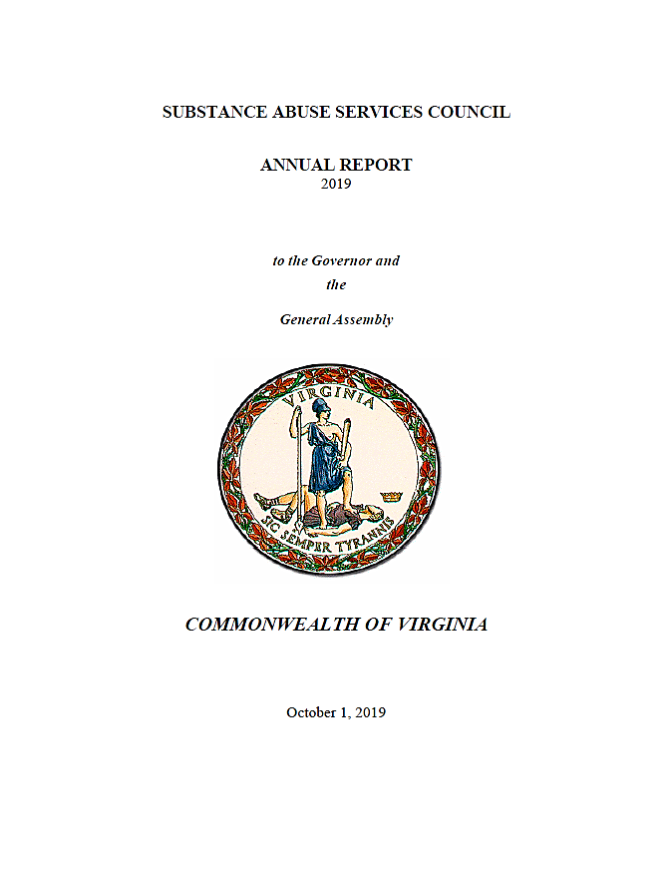

**2023**

**December 5, 2023**



**State Senator John Bell,**

**Council Chair**

**Virginia Addiction & Recovery Council**

January 25, 2023

To: The Honorable Glenn Youngkin

And

Members, Virginia General Assembly

In accordance with §2.2-2696 of *Code of Virginia*, I am pleased to present the 2023 Annual Report Letter of the Virginia Addiction & Recovery Council (VARC) formerly named the Substance Abuse Services Council (SASC). The *Code* charges the council with recommending policies and goals relating to substance use and dependence and with coordinating efforts to control substance use which is included in the Interagency VARC Report. It also requires the council to make an annual report in the form of this letter on the presentations it received and its activities. The membership of the council includes representatives of state agencies, state delegates, state senators, and representatives of provider and advocacy organizations appointed by the Governor.

On behalf of the council, I appreciate the opportunity to provide you with our annual report identifying major themes in the council’s work in 2023 and highlighting focuses, contributions, and recommendations from the council based on its work this year. We hope it will contribute to improving the lives of the many Virginians affected by substance use disorders.

Sincerely,

State Senator John Bell

VARC Chairperson

Cc:

The Honorable John Littel, Secretary of Health and Human Resources

Nelson Smith, Commissioner, Department of Behavioral Health and Developmental Services (DBHDS)

**2023 VARC Annual Report**

In 2023, VARC worked to expand its representation of stakeholders in treating addiction and broaden its subject matter expertise by adding representatives from the Virginia Council on Problem Gambling and the Opioid Abatement Authority. VARC received a presentation from the Cannabis Control Authority and the Council will seek to add more representation related to marijuana control and treatment as the process of legalization continues to develop. VARC continued its duties in collecting information, receiving presentations, and utilizing its multidisciplinary network of leaders in the substance use disorder (SUD) and addiction fields to better inform policy and practice in the public and private sectors about reducing barriers to treatment and prevention. In 2023, VARC continued to meet in person and will have conducted its 4 meetings per calendar year. During those meetings, VARC representatives shared agency and legislative updates, received presentations from experts across the behavioral health field, shared recommendations and initiatives amongst governmental agencies, community organizations, and private providers, and heard public comment. Additionally, VARC continued to fulfill its advisory capacity to DBHDS and the Commonwealth regarding requests for information and recommendations for improving policy and procedure.

**Legislative Initiative Endorsed by VARC during 2023**

1. **SB 824 Substance Abuse Services Council; name change, membership- *Passed*-**

* Substance Abuse Services Council; name change; membership. Renames the Substance Abuse Services Council as the Virginia Addiction Recovery Council
* Increases from 29 to 32 the membership of the Council by adding two members
  + One member representing the problem gambling recovery community and one member representing the board of directors of the Opioid Abatement Authority.

**Subject Matter Expertise and Data Presentations Received in 2023**

***Update on the Opioid Abatement Authority and Opioid Settlement Funds-***

***Presented by Tony McDowell- Opioid Abatement Authority***

* In late 2017 a federal judicial panel consolidated all Federal opioid related litigation into single multi district litigation (MDL). In late 2021-early 2022, the Virginia Attorney General’s office worked with local attorneys and outside counsel representing localities, and with numerous associations, to encourage cities and counties to participate and drop individual suits.
  + Resulted in a signed **Virginia Allocation MOU** between all 133 cities/counties and the Commonwealth.
  + General Assembly passed a statute that closely mirrors the MOU.
  + The MOU and the statute specify that **only cities, counties, and state agencies are eligible to receive financial support from the OAA**.

**Virginia’s Settlement Distribution Agreement**

The Statutory Requirements on the use of OAA Funds Exceed the Requirements of the National Settlement Agreements. 100% of the OAA’s disbursements to cities, counties and state agencies must be spent on abatement efforts. There is no reimbursement of previous costs or supplanting allowed. No indirect charges allowed. Recipients must report outcomes to OAA on an annual basis and allow OAA to monitor the programs.

Before discussion of how the funds are distributed, it is important to first understand what “abatement” means. This term appears throughout the national settlement agreements. Also, it is a key provision of hthe Virginia Allocation MOU and the State Code. It Has specific legal meaning, and yet is broad in its applicability. An understanding of what is – and is not – “abatement” is important. Part of the OAA Board’s responsibility is to determine what qualifies as abatement when making decisions about financial support.

Abatement is defined as efforts designed to treat, prevent, or reduce opioid use disorder or the misuse of opioids or otherwise abate or remediate the opioid epidemic, which may include efforts to:

* Support treatment of opioid use disorder and any co-occurring substance use disorder or mental health conditions through evidence-based or evidence-informed methods, programs, or strategies;
* Support people in recovery from opioid use disorder and any co-occurring substance use disorder or mental health conditions through evidence-based or evidence-informed methods, programs, or strategies;
* Provide connections to care for people who have, or are at risk of developing, opioid use disorder and any co-occurring substance use disorder or mental health conditions through evidence-based or evidence-informed methods, programs, or strategies; Support efforts, including law-enforcement programs, to address the needs of persons with opioid use disorder and any co-occurring substance use disorder or mental health conditions who are involved in, or are at risk of becoming involved in, the criminal justice system through evidence-based or evidence-informed methods, programs, or strategies;
* Support drug treatment and recovery courts that provide evidence-based or evidence-informed options for people with opioid use disorder and any co-occurring substance use disorder or mental health conditions; Support efforts to address the needs of pregnant or parenting women with opioid use disorder and any co-occurring substance use disorder or mental health conditions and the needs of their families, including infants with neonatal abstinence syndrome, through evidence-based or evidence-informed methods, programs, or strategies;
* Support efforts to discourage or prevent misuse of opioids through evidence-based or evidence-informed methods, programs, or strategies; Support efforts to prevent or reduce overdose deaths or other opioid-related harms through evidence-based or evidence-informed methods, programs, or strategies; and support efforts to provide comprehensive resources for patients seeking opioid detoxification, including detoxification services.

Examples of efforts that are likely to qualify as “abatement” include:

* Prevention programs including within schools
* Detox services that include opioid-related detoxification
* Naloxone training and distribution
* Treatment services including medication-assisted treatment
* Programs to divert people from jail to treatment, including drug courts
* Recovery housing, linkages to transportation, job training, employment
* Behavioral health crisis programs if there is a clear connection to serving people with opioid use disorders as a central component of the program

The use of funds will be tracked in accordance with Code of Virginia § 2.2-2370 and all expenditures of OAA funds shall be conducted or managed by a participating locality or state agency. Every city and county is required by law to conduct an outside audit and report its expenditures to the state (Code of Virginia § 15.2-2511). Expenditures and performance measures must also be reported to the OAA and OAA will performs site visits and inspections with any concerns potentially resulting in detailed financial and programmatic reviews. Applications for grants utilizing OAA funds were open earlier in the year and going forward the application timeframe will run Oct 1 to April 1 each year.

***Cannabis in the Commonwealth- Presented by Brianna Bonat & Jake Shuford, Cannabis Control Authority***

As an independent, apolitical subdivision of the Commonwealth, the Cannabis Control Authority (CCA) promotes public safety, advances public health, and protects communities in Virginia through effective medical cannabis oversight and balanced and inclusive cannabis regulation, policy, and education.  CCA serves roles including regulator, policy advisor, and educator in the Commonwealth and CCA implements policies made by elected officials.

Currently, medical cannabis, limited home cultivation, and limited possession and adult sharing are legal in the Commonwealth. In regards to medical cannabis, an individual with medical conditions that meets basic qualifications and has been issued a written certification by a licensed practitioner can purchase cannabis products from a licensed dispensary.

For home cultivation, cultivation of up to 4 plants in primary private residence for those 21+ is legal. Plants must be properly labeled, must not be visible from public areas, and access must be prevented by minors

Regarding limited possession and adult sharing, possession for personal use at residence for adults 21+ is legal and public possession up to 1 oz. for adults 21+. Adults 21+ can privately share up to 1 oz. of marijuana with other adults 21+ without compensation

Current what is illegal includes:

* Retail sales outside of the medical cannabis program
* Possession of any amount with intent to distribute
* Possession or consumption by anyone under 21
* Possession of any amount on school grounds or school bus
* Giving marijuana in exchange for something else (e.g., another product/service)
* Home cultivation of more than 4 plants, or for retail use
* Gifting schemes
* Public possession of more than 1 oz. of marijuana
  + More than 1 oz. and up to 4 oz. is a civil penalty
  + More than 4 oz. and up to 1 lb. is a criminal offense (misdemeanor)
  + More than 1 lb. is a felony
* Using or sharing cannabis in public spaces

There are also several regulations to understand regarding marijuana and the workplace. Most employer "rights" remain intact with the exception of registered medical cannabis patients. Protections for patients are limited. Employers can prohibit impairment, possession during work hours, on work grounds  and are not required to engage in conduct violating federal law or causing loss of federal contract or federal funding

The 2023 legislative updates for the CCA included no changes to retail market, the introduction of the medical cannabis program which encompassed the transition to the CCA, and then increased regulations on hemp-derived products.

Also relevant to regulations for Cannabis in Virginia is the medical cannabis oversight program. It is currently regulated by the Board of Pharmacy. Virginia divided into 5 Health Service Areas with 4 pharmaceutical processors, 16 cannabis dispensing facilities. On January 1, 2024, Regulatory oversight transfers to the CCA.

The CCA has published a number of education resources and fact sheets related to health and safety. It also has promoted a safe driving campaign and survey which demonstrated significant needs for education around safe choices under the influence of cannabis.

***Drug Treatment Court Dockets- Presented by Anna Powers and Danny Livengood***

Drug Courts involve participants voluntarily participating in extended duration (12-15 months) with evidence-based treatment, judicial monitoring, strict supervision with the participant primarily receiving treatment in the community. Drug court graduates include reduced or dismissal of the charges, Reduced or set aside incarceration sentences, and lesser penalties.

Drug court objectives are to:

* Reduce substance use
* Reduce recidivism
* Reduce court workloads
* Increase accountability
* Make planning and use of resources more effective

The target population for drug courts are non-violent offenders that have offenses that are drug related or drug motivated. This includes individuals with a clinical diagnosis of Substance Use Disorder (SUD). These individuals targeted by drug courts often have high risk/high needs.

Drug courts typically last 12-15 months and involve periodic court appearances and drug testing. Collaborative team effort is encouraged as a crucial element in drug court programming which can involve comprehensive treatment and intensive supervision and monitoring. Additional features include: evidence-based treatment, rewards and/or sanctions, as well as employment, housing, medication, and transportation assistance as available/needed.

4 types of models for drug court are available in Virginia. Those are for adults, juveniles, DUI cases, and families. There are currently 53 operational adult drug courts which are the most frequently utilized and most available. Drug courts reduce recidivism, reduce costs, and provide needed services.

Regarding performance, in FY 2022, there were 1,403 active adult drug court participants. For admissions, there were 927 referrals, and 488 new participants were accepted into an adult drug docket. A total of 243 participants successfully graduated an adult drug court docket. Virginia drug courts save $19,234 per person compared to traditional case processing. In FY 2022, Virginia drug courts yielded an estimated cost savings over $4.6 million.

Additional benefits of drug courts include:

• Drug Courts provide opportunities for participants to continue/gain employment and maintain connections with family and community, both critical for their return to society.

• Employed participants pay taxes, rather than cost taxpayers.

• Drug Courts also provide opportunities to keep non-violent offenders

***Long Acting Injectables (LAI) for the Treatment of Substance Use Disorder (SUD) and Serious Mental Illness (SMI) in Hospital Inpatient Settings- Presented by Dr. Douglas Brown- Virginia Society of Addiction Medicine Board***

*The Problem*

* Long-acting injectable (LAI) medications that treat SMI and SUD are not reimbursed by Medicaid (outside of the daily/bundled rate) in hospital inpatient/emergency department settings.
* While certain forms are LAI medications are currently covered on state Medicaid, Managed Care, and Commercial insurance preferred drug lists, reimbursement is typically only allowed in outpatient settings of care and not in hospital settings.
* This is problematic because many patients living with SUD and SMI seek treatment in a hospital setting. Nationally, there are over 380,000 Emergency Department (ED) visits annually involving adults with schizophrenia. About 50% of these visits led to hospitalization.
* Because there is no direct reimbursement for LAIs to treat SUD and SMI, providers are inclined to prescribe oral alternatives.
* Maintaining adherence to oral treatment is often challenging for patients experiencing SMI or SUD, and poor adherence is associated with poor outcomes, including increased risks of relapse, rehospitalization, suicidal and aggressive behaviors, and mortality.
* Nonadherence to antipsychotic medications is well-documented. Compared to oral antipsychotics, LAIs are highly effective in preventing a second episode of psychosis. Without access to LAIs in the hospital setting, individuals experiencing SMI or SUD have greater impacts to their continuity of care and overall health.
* While pharmaceutical companies often provide free trial options, these options, for a variety of reasons, are typically limited to hospitals within communities that serve patients with commercial insurance. This results in disparate access to innovative medicines in those hospitals located in underserved or under resourced communities.

*The Solution*

* By separately reimbursing for LAI medications administered for mental health or substance use disorder in hospital ED and inpatient settings, patients with the complex disease states of SUD or SMI will be better able to access the care they need within hospital settings and reduce the risks associated with a lack of adherence.
* Because LAIs are already (separately) reimbursed in outpatient settings of care, it only makes sense that they are reimbursed in hospital settings as well. Getting access where the patient presents is critical and is directly aligned with the Commonwealth’s effort to ensure that patients with SUD and SMI have the “Right Help. Right Now.”

**VARC- Key Focuses, Contributions, and Recommendations**

***Focuses *some carried over from 2022***

1. Expansion of representation and on the council and education from other stakeholders which included agencies involving non-substance addiction like problem gambling as well as representation from the Opioid Abatement Authority
2. Changed the name of the Council from the Substance Abuse Services Council (SASC) to the Virginia Addiction and Recovery Council (VARC)
3. Identification and continued information sharing regarding emerging and continued trends with substance use in the commonwealth including marijuana dependency and gambling addiction*
4. Focus on networking to foster collaboration among state agencies, legislators, private providers, peer community representatives, and non-governmental organizations through dialogue concentrated on innovation and partnership*
5. Detection of key gaps in services as well as population disparities which cause further barriers to accessing care and the efficacy of prevention and treatment practices*
6. Participation in presentations to help inform leadership in the SUD field in understanding the SUD treatment and prevention landscape in Virginia and to receive the latest trends and advancements in SUD policy and practice.*

***Contributions***

1. Endorsed bill to change the name of the Substance Abuse Services Council (SASC) which used outdated terminology to the Virginia Addiction and Recovery Council (VARC)
2. Provided outreach to potential partner organizations and agencies for more education and participation in VARC
3. Received and shared public feedback from advocates, organization, and people with lived experience who have input ranging from legislative initiatives to experiences in treatment and recovery

***Recommendations***

1. Further presentations to be made to VARC in 2024 with topics that include peer services in carceral settings, recovery housing updates, supported employment services, etc.
2. Creation of waiver process to address the issue of barrier crimes that prevent organizations and agencies from hiring extremely capable individuals with lived experience in settings where they can have a substantial impact in preventing others from negative outcomes associated with substance use
3. Funding of long-acting-injectables in inpatient hospital/emergency department settings for treatment of individuals with substance use disorders and serious mental illness to reduce the likelihood of relapse or rehospitalization upon discharge from inpatient setting and further ensure successful transition to outpatient/community supports and treatment
4. Ensure accountability and oversight for the DBHDS monitoring of credentialed recovery homes for regulatory compliance and consult with the Virginia Association of Recovery Residences to keep the agency's public website's list of credentialed recovery homes up to date.
5. Increased funding to workforce in substance use prevention and treatment to address significant workforce gaps due to staffing shortages especially given the continued troubling trends with opioid addiction and overdose related deaths*
6. Adding members from key stakeholders as laws and regulatory bodies change around addiction which could include the Cannabis Control Authority now that there is a medical program for cannabis and the possibility of full legalization in the near future
7. Identifying and expanding better outcome measures that provide more accurate data on the efficacy of public services to better inform funding decisions so that funds are not just allocated based on historical precedence but to the agencies, organizations, communities, and providers with the highest quality services and those that meet the needs of clients in their area.*
8. Reducing the barriers in the state system for clients to access care through the funding and partnership with non-governmental organizations in the community*
9. Continued proliferation and training for professionals across fields that interact with clients with SUDs to administer NARCAN which is a crucial tool for reducing accidental overdose*